**Lab 3**

**To Construct Logic Circuits with the help of Boolean Expressions and Vice Versa**

**Hint: For Standard Canonical SOP form we use min-terms and for POS we use max-terms**

**Task 1**

**Identify the logic expression for the circuits given below. Construct the truth table with the help of expression and simulate the circuits to verify each of the truth table. Paste your screenshots here.**

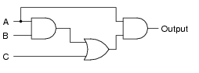

First, identify the gates:

Output Expression=

**Truth Table**

|  |  |  |  |
| --- | --- | --- | --- |
| **A** | **B** | **C** | **Output** |
|  |  |  |  |
|  |  |  |  |
|  |  |  |  |
|  |  |  |  |
|  |  |  |  |
|  |  |  |  |
|  |  |  |  |
|  |  |  |  |

**Screenshots of Simulation**

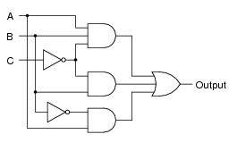

First, identify the gates:

Output Expression=

**Truth Table**

|  |  |  |  |
| --- | --- | --- | --- |
| **A** | **B** | **C** | **Output** |
|  |  |  |  |
|  |  |  |  |
|  |  |  |  |
|  |  |  |  |
|  |  |  |  |
|  |  |  |  |
|  |  |  |  |
|  |  |  |  |

**Screenshots of Simulation**

**Task 2**

**Construct the logic circuit for given expressions and devise a truth table. Simulate the circuit using Logicly software to verify the table. Paste your screenshots for your simulated circuit to verify the expressions.**

1. **Y=ABC +A’B’C+AB’C’+AB’C**

**Circuit Diagram (from logicly)**

**Truth Table**

1. **Z=(A+B’)(A+B)**

**Circuit Diagram (from Logicly)**

**Truth Table**

**Task 3**

**Below is a truth table for a logic circuit. Write Boolean expression using both Canonical SOP form and POS form. Draw the logic diagram from the expression you have devised and simulate that circuit in Logicly. Give all the inputs to it from the above truth table and verity whether your logic expression is correct or not.**

**Paste the screenshot of circuits derived and tested for both the forms (SOP & POS).**

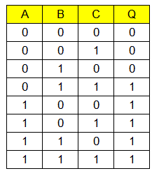

**Expression using SOP=**

**Screenshots of Logic Diagram (SOP)**

**Expression using POS=**

**Screenshots of Logic Diagram (SOP)**